Movie Reviews And Ratings

Use-Case Specification

Version <1.0>

Revision History

| **Date** | **Version** | **Description** | **Author** |
| --- | --- | --- | --- |
| 06/11/2021 | 1.0 | Complete use-case model | Ngo Truong Tuyen |
| 06/11/2021 | 1.0 | Complete use-case:Edit user’s profile, add movie review to favorite list, rate movie review, comment on review, upload review and trailer, view favorite list, view top movie ranking | Bui Huynh Trung Nam |
| 07/11/2021 | 1.0 | Complete use-cases: upload review and trailer, write/edit the movie review description. | Hoang Huu Giap |
| 08/11/2021 | 1.0 | Complete use-case: view movie reviews/trailers and view personal information | Nguyen Phan Vu |
| 09/11/2021 | 1.0 | Complete use-cases: delete a movie review, report to admin and view history activity. | Hoang Huu Giap |
| 09/11/2021 | 1.0 | Complete use-case: classify movie, delete user | Ngo Truong Tuyen |
| 13/11/2021 | 1.0 | Complete use-cases: login account, logout account, register account and searching movie’s name. | Nguyen Tan Viet |

Table of Contents

**Use-case Model** **4**

**Use-case Specifications** **5**

# Use-case Model

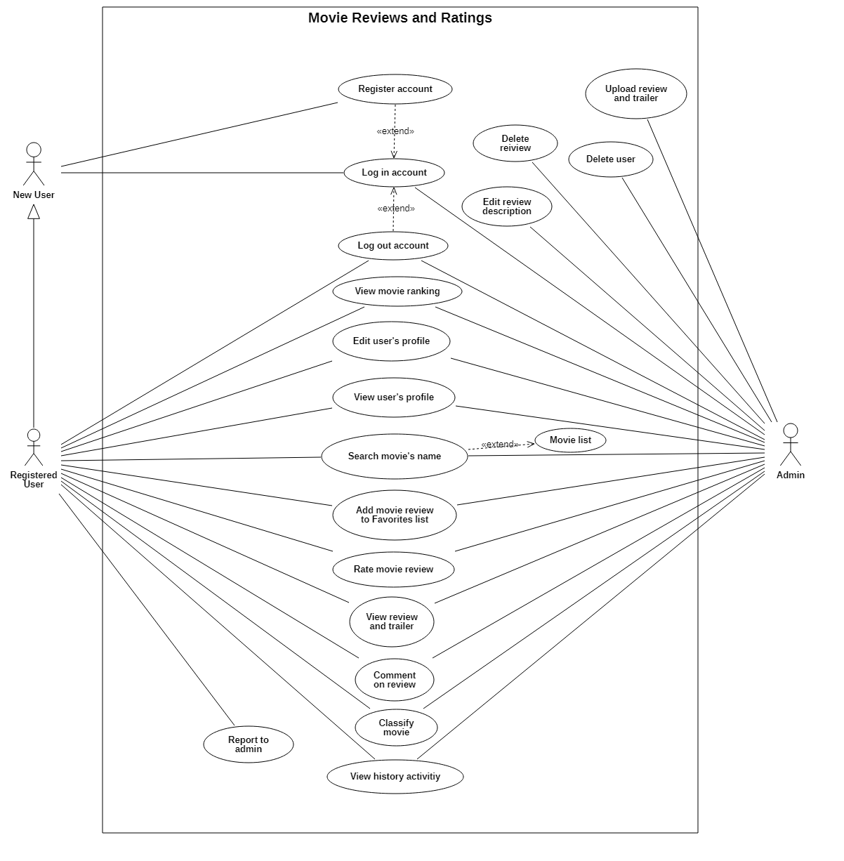

# 

# Use-case Specifications

* 1. **Use-case: Login account**

| Use case Name | Login account |
| --- | --- |
| Brief description | Login to account to get access to system (Web) |
| Actors | User or admin, who want to access to the website via their account |
| Basic Flow | 1. On the login page, everyone will see a login form at the middle 2. User after fill in the id and the password → press “Login” button 3. Server will return home page if login is successful 4. If the id or password are not corrected, the system will notify |
| Alternative Flows | **Alternative flow 1: User forgot password**   1. After failure to login, “forgot password” button will appear. If a user clicks on it, the website will redirect to the “forgot password” page.   **Alternative flow 2: Don’t have account**   1. Users can create a new account via the “don’t have account” button, the website will redirect to the register account page. |
| Pre-conditions | User must be on the login page or access through specific link |
| Post-conditions | Successful login to account |

* 1. **Use-case: Register account**

| Use case Name | Register account |
| --- | --- |
| Brief description | Create a new account to use some of the account's features and website’s features. |
| Actors | User who want to create a new account for the website |
| Basic Flow | 1. On the login page, click on “Registry” button 2. Users must fill in personal information ( name, date of birth, sexual, gmail account, telephone number, address,..), id and password in corrected form. If everything is valid, there will be a successful message 3. Back to login page to login |
| Alternative Flows | **Alternative flow 1: Unsuccess to register**   1. If user do nothing wrong but the account cannot be initial, there will be an message for user to create again   **Alternative flow 2: Incorrect information**   1. If the given information from the user is not correct, the system will force the user to re-enter and have an example. |
| Pre-conditions | User must be on the login page or access through specific link |
| Post-conditions | Success to register a new account |

* 1. **Use-case: Forgot password**

| Use case Name | Forgot password |
| --- | --- |
| Brief description | Support users to find their account if they forgot the password |
| Actors | User who forgot password |
| Basic Flow | 1. On the login page, click on “Forgot your password” button 2. Users must fill in the gmail or phone number which used to register an account, if the id account and gmail exist in the database. System will send a message to that gmail for the user to reset password. |
| Alternative Flows | **Alternative flow 1: Given information are not correct**   1. If the information of an id account or gmail do not exist, the system will send a message to notify the user.   **Alternative flow 2: Incorrect information**   1. If the given information from the user is not correct, the system will force the user to re-enter and have an example. |
| Pre-conditions | User must be on the login page and have problems with account ( cannot access to the account) |
| Post-conditions | re-create user account with new password |

* 1. **Use-case: Logout account**

| Use case Name | Logout account |
| --- | --- |
| Brief description | Logout the current account |
| Actors | User or admin who already login to website |
| Basic Flow | 1. From the edit profile page, press “Logout account”. If successful, it will be redirected to the login page as no account. |
| Alternative Flows | **Alternative flow 1: Unsuccess to logout**   1. If the website does not redirect to the login page, try to logout again. |
| Pre-conditions | User must be on the edit profile page and logged |
| Post-conditions | Logout the account,back to login page with basic view |

* 1. **Use-case: Search movie’s name**

| Use case Name | Search movie’s name |
| --- | --- |
| Brief description | Search movie by movie’s name through search bar |
| Actors | User or admin who already login to website |
| Basic Flow | 1. From the homepage, users can search the movie they want in the searching taskbar. 2. After fill in and press searching button, server will return a list of films with the name as the user entered |
| Alternative Flows | **Alternative flow 1: No matching results found**   1. Server will try to send back movies with the slightly same name 2. Or you can re-enter another movie’s name |
| Pre-conditions | User must be on the homepage |
| Post-conditions | find a list of matching movie |

* 1. **Use-case: View review and trailer**

| Use case Name | View review and trailer |
| --- | --- |
| Brief description | See details review or trailer of a specific movie |
| Actors | Admin, user already has an account, guest (user without account).  In other words, everyone has the right to do this. |
| Basic Flow | 1. On the homepage, users can access the page containing the movie list by search bar or by movie categories on the homepage (hot movie list) or favorite list 2. User click on any movie and the review/trailer page will be opened |
| Alternative Flows | **Alternative flow 1: Visited the page containing the movie list via the search bar but didn't see any movies**  Try searching again with another suitable keyword  **Alternative flow 2: Visited the page containing the movie list via the favorites list, but no movies are found**   1. If the user is not logged in, there will be a prompt message 2. If the user has not added any movies to this list there will be a status line "You have not added any favorite movies" |
| Pre-conditions | user must be on the homepage or the page containing the list of movies, or have the link to the specific movie |
| Post-conditions | Successful access to specific movie page |

* 1. **Use-case: View user’s profile**

| Use case Name | View user’s profile |
| --- | --- |
| Brief description | View details of current account |
| Actors | User has registered an account and is logging in with that account |
| Basic Flow | 1. From the homepage, click on the user profile 2. access to user profile |
| Alternative Flows | **Alternative flow 1: User doesn't see any thumbnails on homepage**   1. Make sure the user is signed in to an account. |
| Pre-conditions | User must login with account and on the homepage or have the link to the personal information page |
| Post-conditions | Successful access to personal information page |

* 1. **Use-case: Edit user’s profile**

| Use case Name | Edit user’s profile |
| --- | --- |
| Brief description | Edit, change personal information such as name, age, avatar,... |
| Actors | Admin or user logged account |
| Basic Flow | 1. On homepage, users clicks on user profile to access profile 2. Users can clicks on a button beside each field 3. System displays box or service to change information 4. User clicks “finish” to finish the action 5. System update the information for the account |
| Alternative Flows | **Alternative flow 1: Profile does not update after editing**   1. From #5 of the basic flow, user should wait for minutes after editing and refresh after that 2. If profile still does not update, re-edit again, starting from #1 of the basic flow   **Alternative flow 2: Profile edit unsuccessfully**   1. This result happens when people enter incorrect information such as age is a negative number. Re-edit again, starting from #2 of the basic flow |
| Pre-conditions | Logged users have already logged on website |
| Post-conditions | personal information will be updated |

* 1. **Use-case: Rate movie review**

| Use case Name | Ratings movie review |
| --- | --- |
| Brief description | Ratings movie (from 1 start to 5 start) for each movie review |
| Actors | Admin, user logged account |
| Basic Flow | 1. On homepage, user can access a movie by use-case 2.6: view review and trailer 2. In the page showing movie, user can scroll to bottom of page 3. In the bottom we can rate a movie by click on 1 to 5 starts 4. System will update the number of users rating the movie |
| Alternative Flows | **Alternative flow 1: User upload movie unsuccessfully**   1. Refresh page and re-rating again |
| Pre-conditions | Users have already logged in website and access to movie page |
| Post-conditions | Rating of the movie will be update |

* 1. **Use-case: Upload review and trailer**

| Use case Name | Upload review and trailer |
| --- | --- |
| Brief description | Ratings movie (from 1 start to 5 start) |
| Actors | Admin |
| Basic Flow | 1. On homepage, admin will see “add new movie” button 2. Click on the button, web will open a page to add new movie 3. Admin can write script, content, review and add trailer in the page 4. Click on “finish” button to finish action 5. System will update and add new movie |
| Alternative Flows | **Alternative flow 1: Admin upload movie/ trailer unsuccessfully**   1. From #5 of the basic flow, user should wait for minutes 2. If profile still does not update, re-upload again, starting from #1 of the basic flow   **Alternative flow 2: If the movie has already had on web**   1. Content/review/trailer will be update |
| Pre-conditions | This user needs to be an administrator and logged by this account to website |
| Post-conditions | After finishing all conditions, the system will upload this new movie review to the realtime database (Firebase) and show it on the website. |

* 1. **Use-case: Add movie review to favorite list**

| Use case Name | Add movie to favorite list |
| --- | --- |
| Brief description | save/unsave movie review to favorite list |
| Actors | Admin, user logged account |
| Basic Flow | 1. On homepage, user can access a movie by use-case 2.6: view review and trailer 2. In the page showing movie, user will see a “save” or “unsave” button in top right corner 3. Click on the button top add this movie to favorite list 4. System will add the movie to favorite list |
| Alternative Flows | **Alternative flow 1: Conflict when click repeatedly a button**   1. if user click one button 2 time or unsave a move if user has not already save it, nothing happen |
| Pre-conditions | Admin, user logged in website and access to movie page |
| Post-conditions | Movie will be upload on website |

* 1. **Use-case: View favorite list**

| Use case Name | View favorite list |
| --- | --- |
| Brief description | Watch user favorite review |
| Actors | Admin, user logged account |
| Basic Flow | 1. On homepage, access favorite list by click on “favorite list” button 2. access to the list |
| Alternative Flows | **Alternative flow 1: Nothing in favorite list**   1. if nothing in list → refresh page 2. if still do not have anything, it’s because user do not add any movie review |
| Pre-conditions | Admin, logged user in website and access to movie page |
| Post-conditions | Favorite list of review |

* 1. **Use-case: Comment on review**

| Use case Name | Comment on review |
| --- | --- |
| Brief description | Comment on movies by account |
| Actors | Admin, user logged account |
| Basic Flow | 1. On homepage, user can access a movie by use-case 2.6: view review and trailer 2. In the page showing movie, user can scroll to bottom of page 3. In the bottom user can comment on this movie 4. System will update the comment |
| Alternative Flows | **Alternative flow 1: User comment unsuccessfully**   1. waiting for minutes for system update comment, if nothing still happen, go to step 2 2. Refresh page and re-comment again |
| Pre-conditions | Users have already logged in website and access to movie page |
| Post-conditions | Comment will be updated for this movie |

* 1. **Use-case: Classify movie review**

| Use case Name | Classify movie review |
| --- | --- |
| Brief description | All movie reviews will be classified by category or nation |
| Actors | Admin, user logged account |
| Basic Flow | 1. In “Homepage”, click on the “classify” button 2. Click on the type that it will be used to classify. |
| Alternative Flows | **Alternative flow 1: The movie reviews classified by condition**   1. The system reloads and shows a list of movie reviews by group. |
| Pre-conditions | Users view is the homepage. |
| Post-conditions | The system must return the classified list of movie reviews |

* 1. **Use-case: Delete user**

| Use case Name | Delete user |
| --- | --- |
| Brief description | Delete user account from database |
| Actors | Admin |
| Basic Flow | 1. On homepage, go to the “Admin page” 2. Click on the account which want to delete 3. Click on the “Delete account” |
| Alternative Flows | none |
| Pre-conditions | The device, it will be used to login, must have an Internet connection.  The user’s account that user login the website is admin account. |
| Post-conditions | After the admin clicks on the “Delete account” button, the user’s account will be deleted in the online database. |

* 1. **Use-case: Edit review description**

| Use case Name | Edit review description |
| --- | --- |
| Brief description | The admin can rewrite or edit the movie review description (movie name, trailer, review, actors,...) |
| Actors | Admin |
| Basic Flow | 1. On homepage, the admin can access a movie by use-case 2.6: view review and trailer 2. Admin chooses one from that list. 3. This movie review page will show up. 4. Admin click to edit button (this button only visible to admin account). 5. Admin starts editing. 6. After editing, the admin clicks the submit button to finish action. |
| Alternative Flows | **Alternative flow 1: Admin doesn’t need to use search bar**   1. In homepage, if admin see the film review need to be updated, admin can click to that movie in order to go directly to step #5 without searching. |
| Pre-conditions | This user needs to be an administrator, ddmin logged in website. |
| Post-conditions | After the admin press submit button. New movie descriptions will be updated and the system also updates this change in database. |

* 1. **Use-case: Delete review**

| Use case Name | Delete review. |
| --- | --- |
| Brief description | The administrator can delete any movie review from the website. |
| Actors | Admin |
| Basic Flow | 1. On homepage, user can access a movie by use-case 2.6: view review and trailer 2. Admin chooses one from that list 3. This movie review page will show up. 4. Admin click to delete button (this button only visible to admin account). 5. The system shows a confirm button. 6. The admin needs to press the confirm button to finish this action or press cancel button to reject this action. |
| Alternative Flows | **Alternative flow 1: Admin doesn’t need to use search bar**   1. In homepage, if admin see the film review need to be deleted, admin can click to that movie in order to go directly to step #5 without searching. |
| Pre-conditions | This user needs to be an administrator, admin logged in website |
| Post-conditions | After the admin presses the confirm button. This movie review will be deleted from the website and realtime database. |

* 1. **Use-case: Report to admin**

| Use case Name | Report to admin |
| --- | --- |
| Brief description | Registered users can report to the admin about bugs, wrong reviews or any user who spam comments. |
| Actors | Registered users (logged users) |
| Basic Flow | 1. On the homepage, users press the “more” button. 2. A list of buttons will show. 3. Users press the “report to admin” button. 4. Users will be directed to a report page. 5. Users need to fill in form 6. After finishing, users press the submit button. |
| Alternative Flows | **Alternative flow 1: Users can press to “report to admin” button in any movie review**   1. If users are watching a movie review and detect any problem (wrong description, wrong director, wrong actors…). User can directly press to “report to admin” button and go to step #5. |
| Pre-conditions | This user must login to the website. |
| Post-conditions | After the admin received this report and fixed it. Users will receive a thank you notification.. |

* 1. **Use-case: View history activity**

| Use case Name | View history activity |
| --- | --- |
| Brief description | Registered users can see their history activity. |
| Actors | Registered users (logged users) and admin. |
| Basic Flow | 1. On the homepage, users click to the user’s thumbnail. 2. A list of buttons will show. 3. Users press the “history” button. 4. Users will be directed to a history page. |
| Alternative Flows | **Alternative flow 1: Users can go to the user's profile page and click the history button.**   1. From #2, users can press the “profile” button. 2. Users will be directed to a user’s profile page. 3. In this page users can press the “history” button and continue step #4. |
| Pre-conditions | This user must login to the website. (registered user or admin) |
| Post-conditions | The user successfully views their history activity, including last login time, all the movie reviews they have seen... |

* 1. **Use-case: Delete comment**

| Use case Name | Delete comment |
| --- | --- |
| Brief description | Delete user’s comment |
| Actors | Admin, logged user |
| Basic Flow | 1. On homepage, user can access a movie by use-case 2.6: view review and trailer 2. In the page showing movie, user can scroll to bottom of page 3. In the bottom user can see user’s comment on this movie 4. beside each comment, having a button to delete, click on the button to delete comment |
| Alternative Flows | **Alternative flow 1: User and the admin delete in the same comment at the same time**   1. A alert announce that the comment has been already deleted will appear 2. Refresh page, the comment will be deleted |
| Pre-conditions | 1. This user must login to the website. 2. User can delete only comment of user, admin can delete all comment |
| Post-conditions | The comment will be deleted from the website. |

* 1. **Use-case: View movie ranking**

| Use case Name | View movie ranking |
| --- | --- |
| Brief description | View movie recently |
| Actors | Admin, logged user |
| Basic Flow | 1. On home page, user can see a list of hot movie at the center of page 2. Scroll and click on any movie to access review page |
| Alternative Flows | **Alternative flow 1: The movie (hot) just uploaded has not been updated yet**   1. All you need to do is refresh page, new movie will be add in the list |
| Pre-conditions | This user must be in homepage |
| Post-conditions | Having a list hot movie reviews |